
Year 9

Semester One Exam-Section 1

No resources allowed

Name: ______________________ Class: ______ Time: 15 minutes Total Mark(1):____/14
Total Mark(1+2):____/52

Questions 1 to 6 are multiple choice and you need to circle your answer.
[6 marks]
- Which of the following ratios is equivalent to 6 : 10?
A 4 : 6 B 9 : 15 C 10 : 20 D 30 : 35

- Mary’s age and her daughter’s age are in the ratio 11 : 3. If Mary is aged 44, how old is her daughter?
A 6 B 9 C 12 D 22

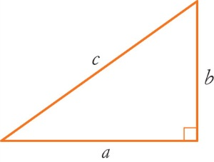
- Which of the following sides is the hypotenuse of this triangle?
A a B b

C c D a or b

- Which of the following mathematical statements is false?

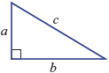
A B C

D E

- For the right-angled triangle shown, the value of x is given by:
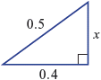

A B C

D E

- Which graph is in direct proportion?
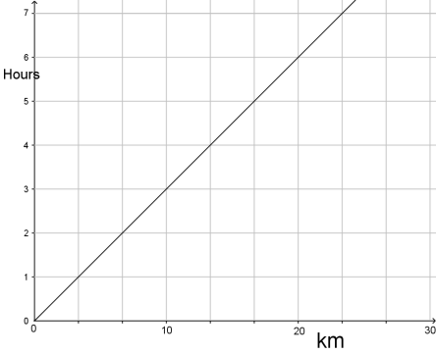
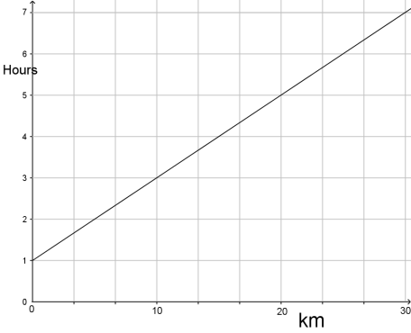
A B

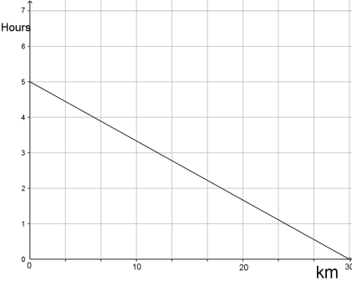
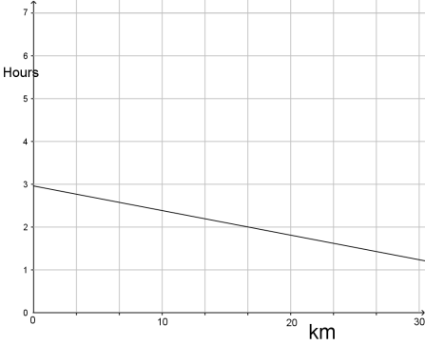
C D

- Simplify the following ratios
[4 marks]
  - $10 :5$

  - $\frac{1}{2}:\frac{2}{3}$

  - $1\frac{2}{5}:\frac{1}{4}$

  - $0.3:1.2$

- Which of the following pairs of ratios are in proportion?
[4 marks]

First | Second | In Proportion  Yes/No
1:2 | 12:24
10:16 | 25:40
12:15 | 30:24
1:0.4 | 5:2


Year 9

Semester One Exam-Section 2

Resources allowed-Scientific calculator/One page of notes

Name: ______________________ Class: ______ Time: 35 minutes Total Mark(2):____/38

Questions 9 to 10 are multiple choice. Circle the correct answers.
[2 marks]
- Ben rides his bike for minutes and travels 750 m. What is his average speed?

A 150m/min B 250m/min C 300m/min D 350 m/min

- In its simplest form, the ratio 60c : $5 is:

A 60 : 5 B 3 : 20 C 1 : 8 D 3 : 25 E 6 : 50

- A car travels 100km on 7.5L of petrol. How far would the car travel with 48L of petrol? Show your working.
[2 marks]

- It takes 40 minutes to travel from Baldivis to Perth at an average speed of 65km/hr. How long would the journey take if the average speed increased to 80km/h? Show your working
[3 marks]

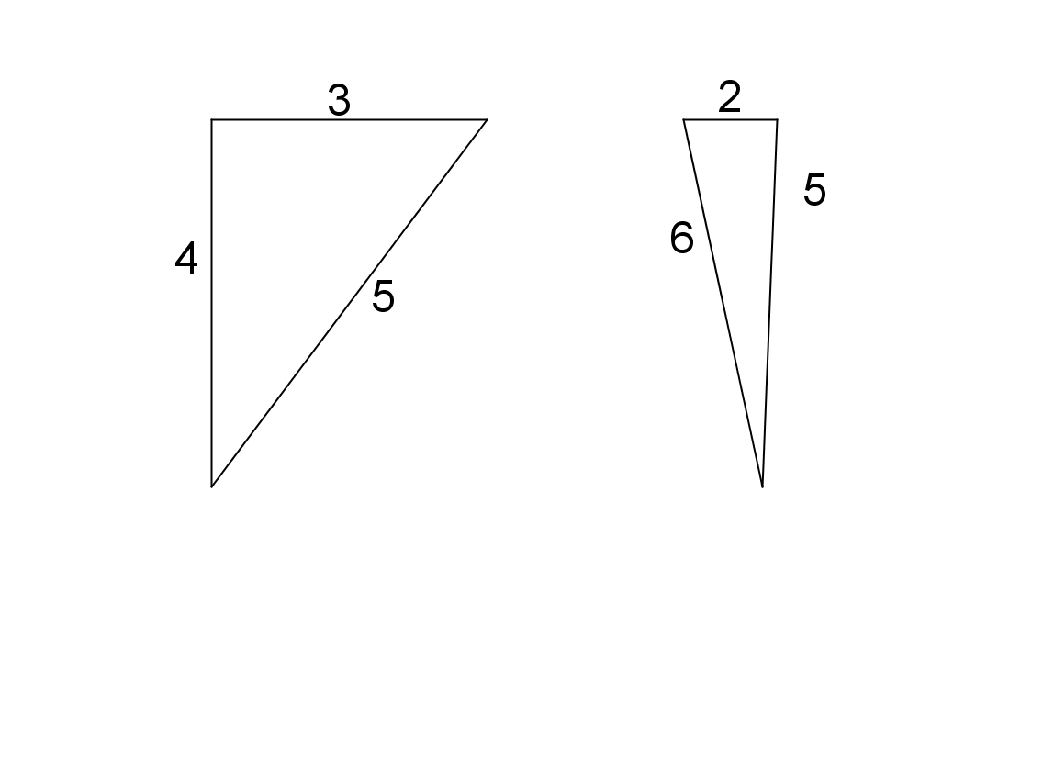
- Are the following right angled triangles. Justify your answer.

[4 marks]
a. b.

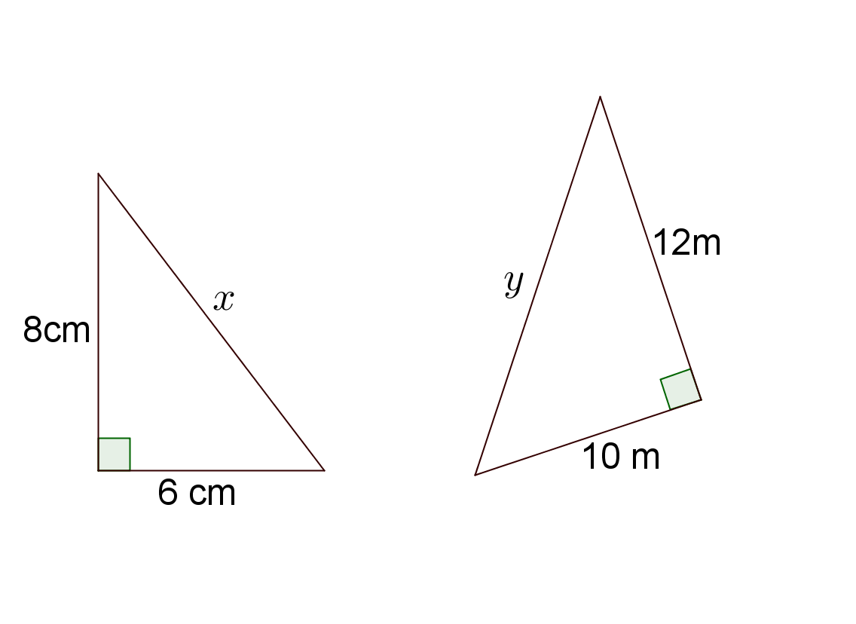
- Find the length of the hypotenuse in the following triangles. Give your answer correct to two decimal places.

[4 marks]
a. b.

- Find the value of the pronumeral in these triangles. Give your answer correct to two decimal places.
[5 marks]
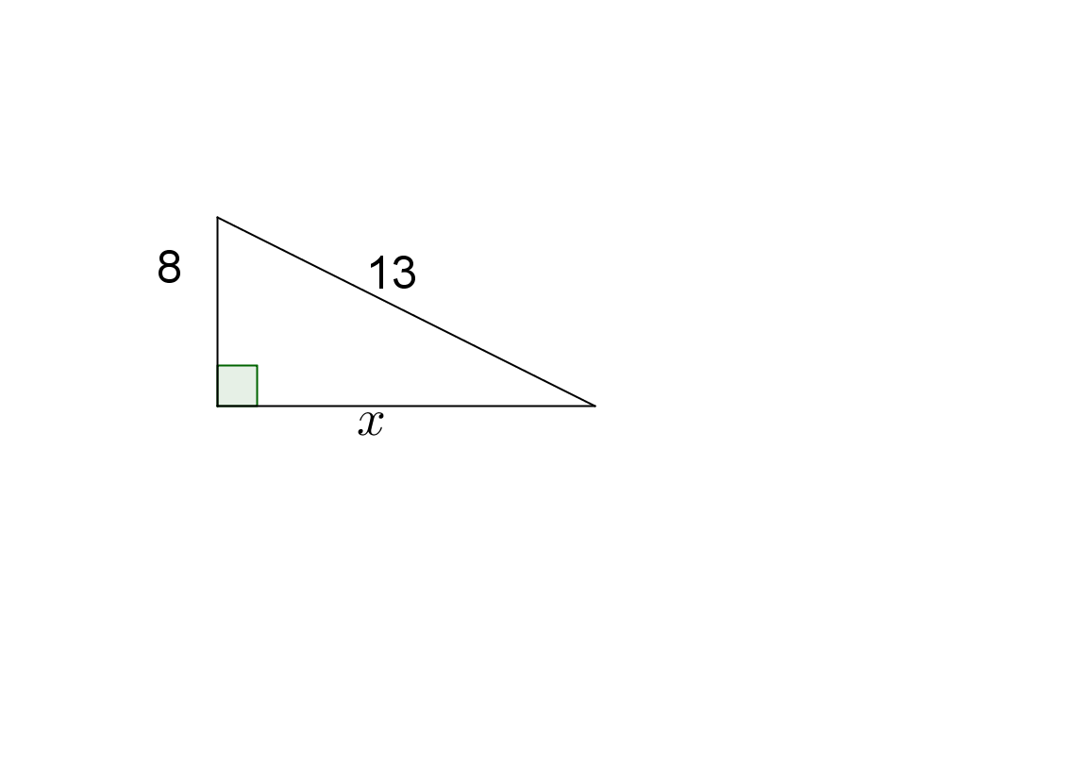
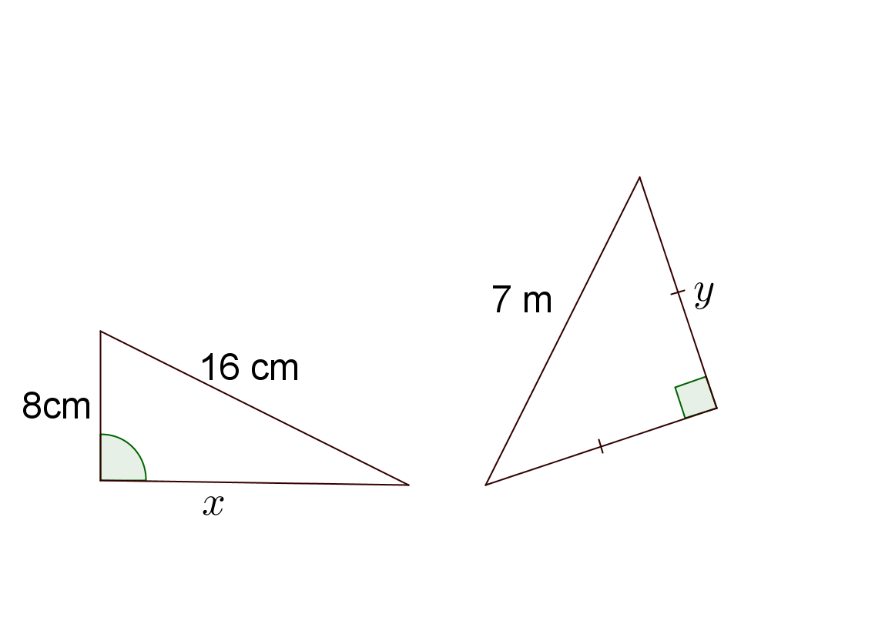

- A 4 m tall ladder reaches 3.7 m up a wall. Find the horizontal distance between the base of the wall and the ladder. Give your answer correct to two decimal places.
[3 marks]

- Two polesTwo poles are located 3.2 m apart. A wire links the tops of the two poles. Find the length of the wire if the poles are 3.8 m and 6 m in height. Give your answer correct to one decimal place.
[3 marks]

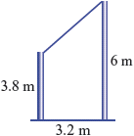

- A rectangular gate measures 1.4 m by 2.5 m with a 2.79m diagonal. Is the gate square? Justify your answer.
If not, should the diagonal be longer or shorter?
[3 marks]

- Find the length of the line AB in the following questions. Give your answers correct to two decimal places.
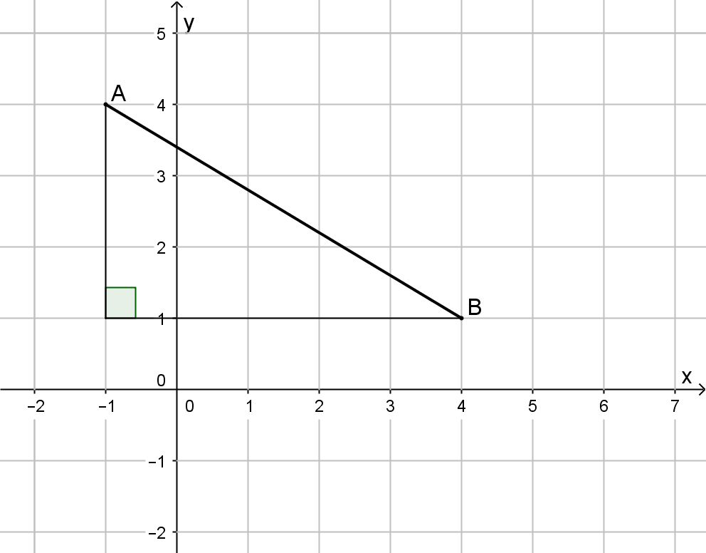
[5 marks]

  - $A\left(-2,3\right)$ and $B(10,-2)$

- Consider the following rectangular prism.
[4 marks]
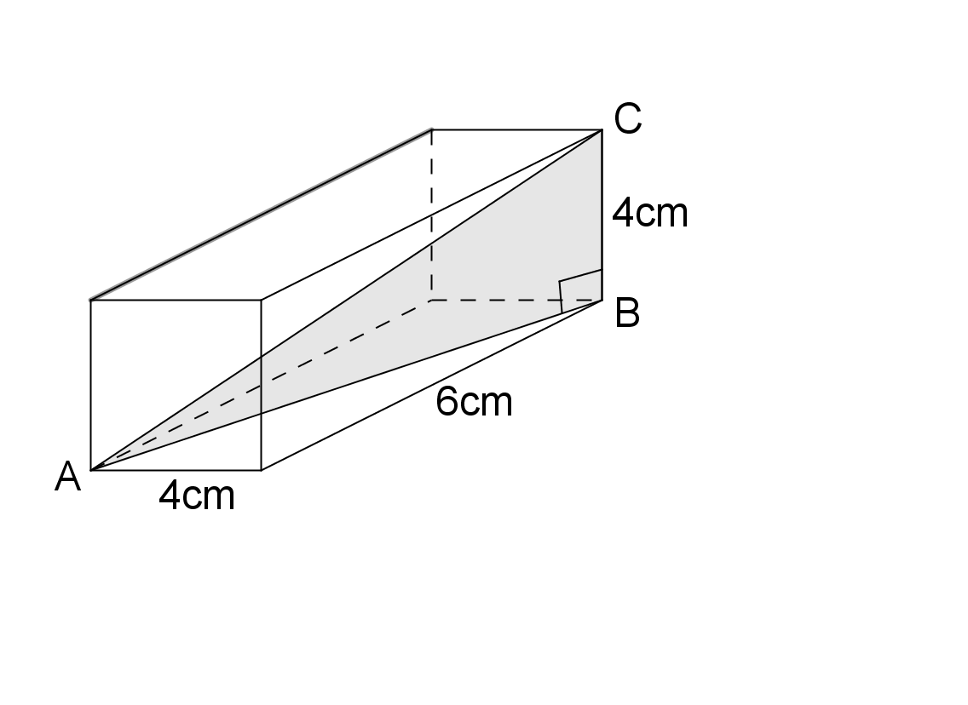

  - Find the length AB as an exact value.

  - Hence, find the length AC. Round your answer to two decimal places.

